**Mississippi**

*Profile Output*

*Top 20* Functions:

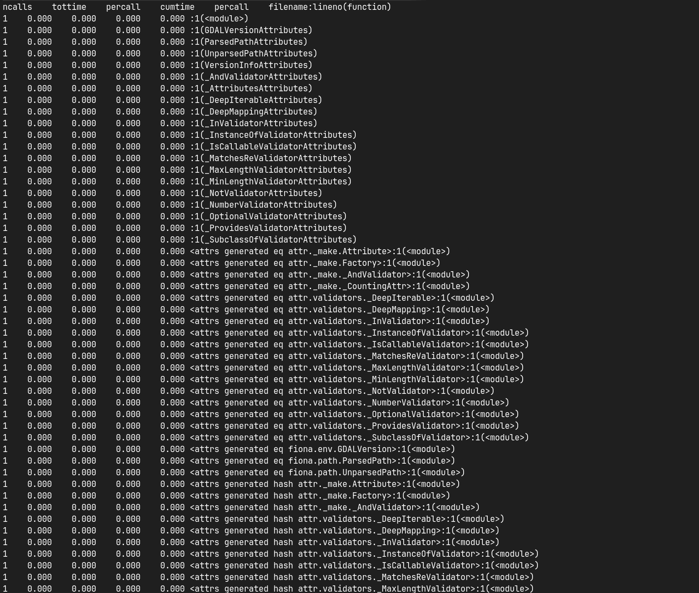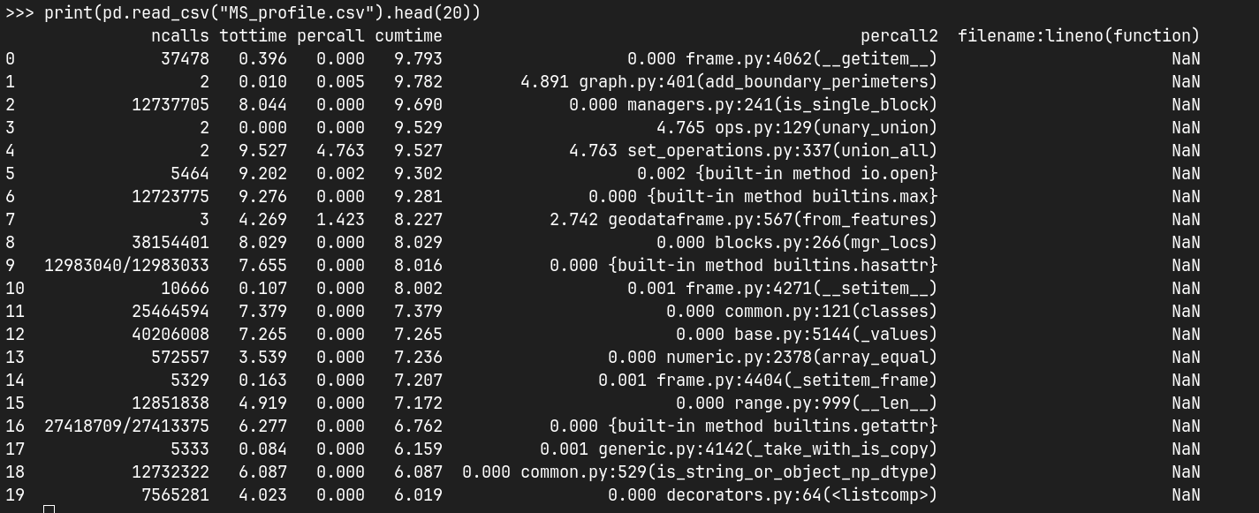

**New York**

*Profile Output*

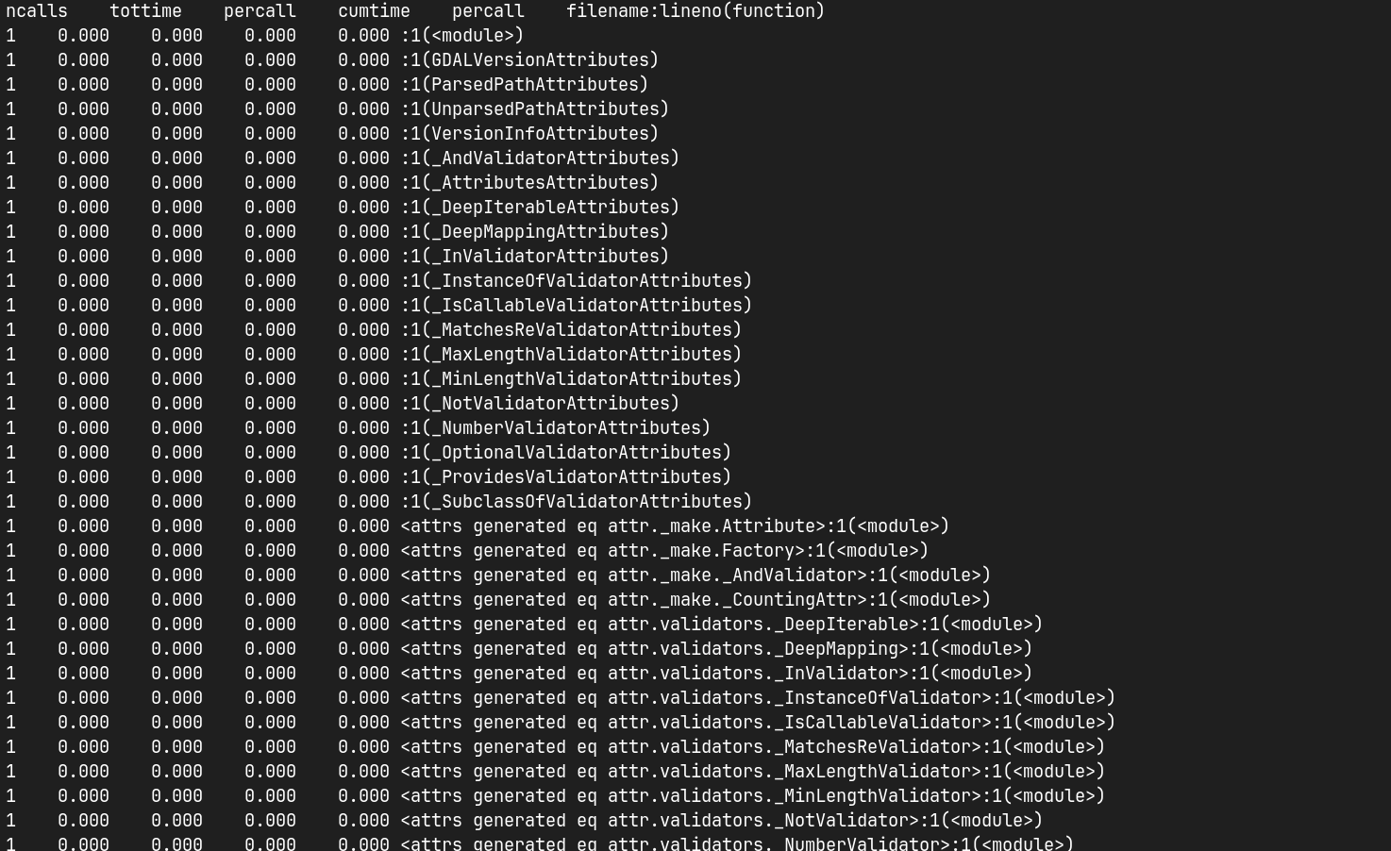

*Top 20 Functions:*

